Casino nea

A brief guide to how I constructed a top down 2D platformer casino
  - Gevin Chendhilkumar

Contents
1 Analysis 1
1.1 The project identification and background 1
1.2 Objectives 3
1.3 Research 3
1.3.1 Interviews/Surveys 3
1.3.2 Technical/Skills research 3
1.3.3 Research Table 3
1.4 Prototypes 3
1.5 Justification of chosen solution 3
1.6 Initial Modelling 3
1.6.1 Story Board 3
1.6.2 Database Modelling 3
1.6.3 Identification of objects and object–analysis diagrams 3
1.6.4 Sketches and process flow of proposed output 3
1.6.5 Data flow diagrams (DFDs) 3
1.7 Analysis Data Dictionary 3
2 Design 3
2.1 Design Introduction 3
2.2 Hierarchy chart 3
2.3 Structure chart 3
2.4 Complex Code 3
2.5 Object diagrams and class definitions 3
2.6 Prototyping 3
2.7 Design data dictionary and data structures 3
2.8 File organisation 3
2.9 E-R model and diagrams, and normalised database tables 3
2.10 Human–Computer-interface design 4
2.11 System security and integrity of data 4

1 Analysis

The project identification and background
The project is a top-down 2D platform game which models a casino. The player controls a character who is given a set amount of money at the start and plays until they are broke or have made a set amount of money. They will be able to walk around and choose a variety of games to play such as blackjack, poker, or roulette to make money.
The third party will be my brother who will be playing the game to make sure that the game is sufficiently user oriented and easy to play.
Games that have inspired this include other 2D platformers like Undertale and the old Zelda games in terms of design. The advantages of this are that the map will be very easy for the user to navigate and I can give it a retro look, however it does mean that the player will be restricted to the keyboard and will not be able to use a mouse in-game. The actual gameplay is inspired by RDR2 where aside from the main story the player can interact with other characters to gamble and play poker or craps by walking around and sitting at different tables.
The game will initially start out with the user having a base amount of money and they can place bets at different games, and they keep playing until they lose it all. Later, I may develop on this and add a time system where they must get a certain amount of money before a timer runs out.
Some limitations of the system would be that the user would need to know how to play the games inside the casino. During development there may be an opportunity to create instruction pages on how to play each game, but it will not be a priority and only be implemented at the end of the project (if I decide to do so).
  - Objectives
The primary objective of my project is to create a game which simulates a casino, with various games where they player can bet certain amounts of money at each game to increase the total in their wallet, at the risk of having that total decrease as well. The different games available will be:
- Blackjack
- Roullet
- Slot machines
- Craps
- Poker
There will also be a system to track how much money the player has made or lost. They should be able to walk around the casino and choose which game they want to play. Each game must be programmed individually, where I will have to do research to figure out the best possible combination of cards for each player (the human and bots) in each game played, for example the best hand possible in a game of poker.

Research

To flip sprite :
https://stackoverflow.com/questions/67917598/how-to-reverse-image-of-a-rectangle-in-javafx
use of. setScaleX() to -1 or 1 to flip the sprite when it moves left or right.

To generate a background:
https://www.geeksforgeeks.org/java/javafx-canvas-class/
Use of Canvas class to draw a pixel background using the rectangles of same width and height.
Tilemap techniques:
https://developer.mozilla.org/en-US/docs/Games/Techniques/Tilemaps
Use of tilemaps in 2D games.

1.3.1 Interviews/Surveys

1.3.2 Technical/Skills research

1.3.3 Research Table

1.4 Prototypes

1.5 Justification of chosen solution

1.6 Initial Modelling

1.6.1 Story Board

1.6.2 Database Modelling

1.6.3 Identification of objects and object–analysis diagrams

1.6.4 Sketches and process flow of proposed output

1.6.5 Data flow diagrams (DFDs)

1.7 Analysis Data Dictionary

2 Design

2.1 Design Introduction

2.2 Hierarchy chart

2.3 Structure chart

2.4 Complex Code

Moving Sprite
I created a separate class called player where the sprite image is loaded into an ImageView and all functionality such as movement and interaction buttons are added to it. There are two separate Images for the same sprite, with one being a .png and another being a .gif.
Afterwards I created booleans for the WASD keys being pressed, to see if they are being held down or are released.
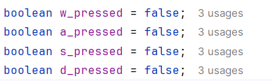
I then set dimensions and set the size of the sprite. I also added event handlers for when keys are pressed, which execute the functions keyPressed() and keyReleased().
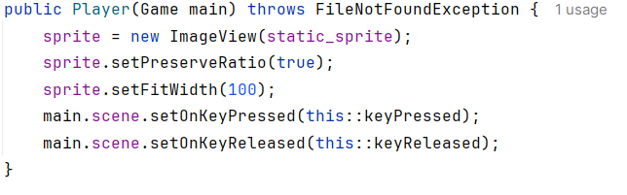
The functions keyPressed() and keyReleased() detect which key is being released, and adjust the Booleans above based on KeyEvent() that is passed.
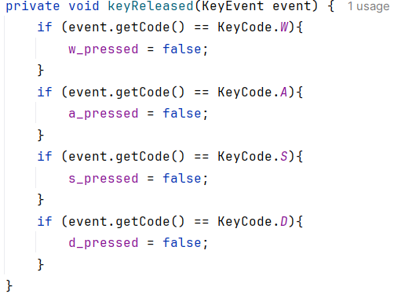
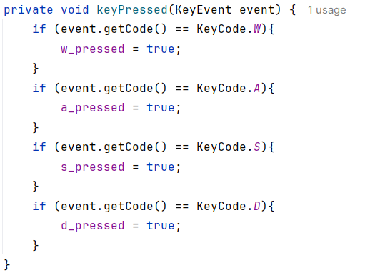
Then I went to the game class and created an object called player. Here I set its x and y coordinates and added it to the root node. Then within the animation timer I called a function called updatePlayer() (located in the player class), where I called the function movePlayer() to move the player around the map. I will also add another function in updatePlayer() for collision detection.
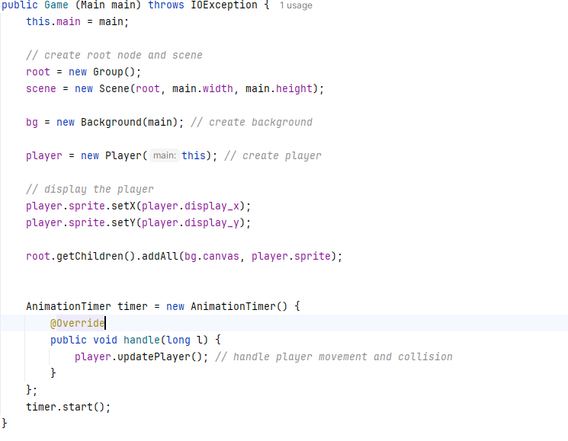
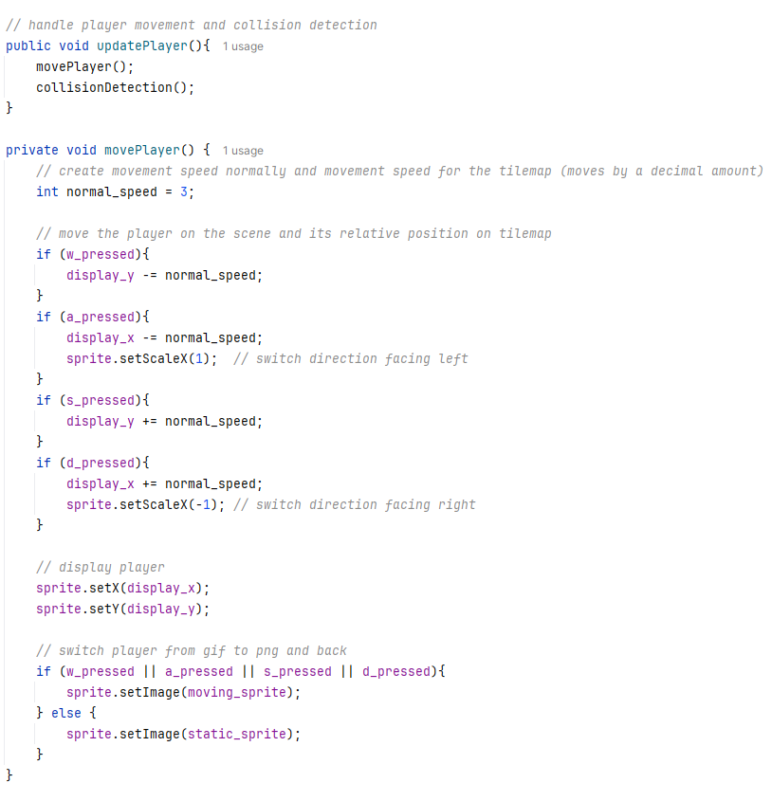
Background

After creating a moving sprite I moved onto the background, I used the Canvas class to draw this out. First I stored a tile map as a txt file separated by commas. I then read this into a 2D array of intergers.
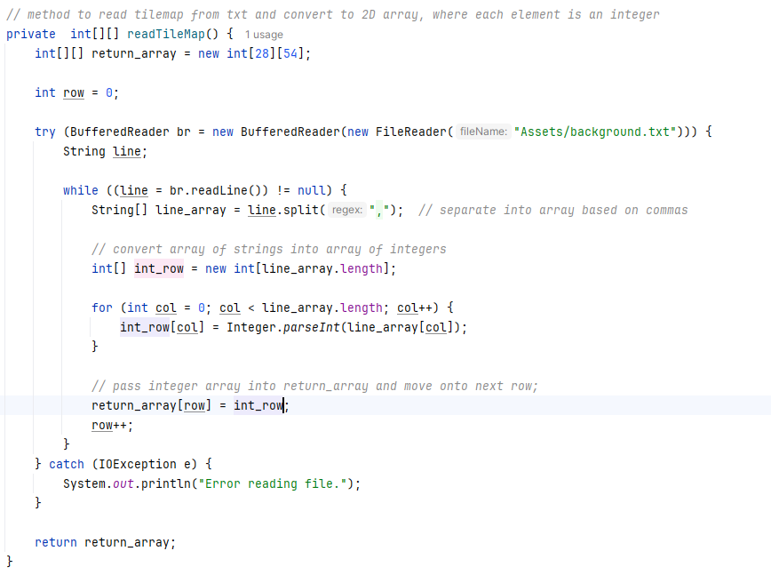
Originally it will start off as a single empty room with green flooring and brown walls, but I will expand it later to include separate rooms.
After this I created a function renderCanvas() to render only the tiles which will be shown on the scene of the game, with a separate function drawTile() used to draw each individual tile using switch cases.
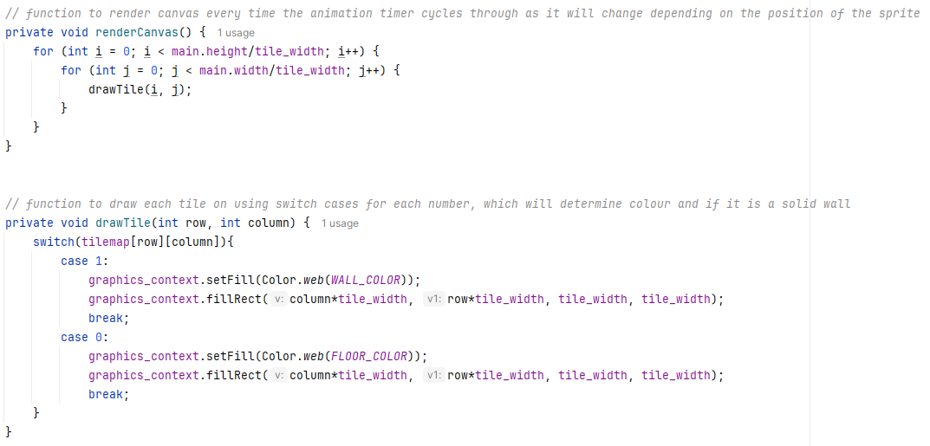
The canvas and graphics context are created in the main method of the class.
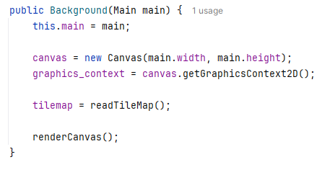
In my Game class, I created a Background object bg and added the canvas to the root node.
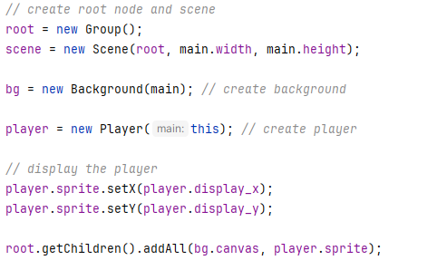

Scrolling background
To do this, I first had to create a camera which constantly regenerates its coordinates based on the position of the player relative to the map. For this, I changed the integers player.x and player.y to player.map_x and player.map_y. This would be doubles instead of integers which represents the players position on the tilemap. To convert it to an actual position on the screen we multiply by tile_width to get the pixel positions and add them to the scene.
Once this was done, it was time to calculate the camera position. Ideally the player should be at the centre of the screen as the background is scrolling, therefore the camera should be calculated half the width and height of the stage to the left and above the sprite. As the camera position is the top left corner of the stage and a coordinate on the tilemap, I had to first create a function which made sure that the camera would not be realigned on the tilemap in such a way that I would be rendering beyond the screen.
To do this I first created a camera in the game class which is calculated based on the sprite’s position relative to the map (at half the stages dimensions). Then I adjusted the rendering function in the background class to draw the map from the appropriate starting coordinates given by the camera. The player’s position is then updated relative to the camera and stage.
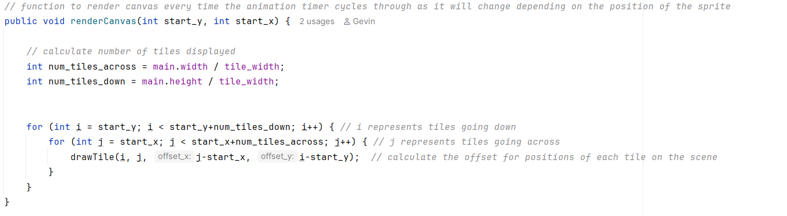
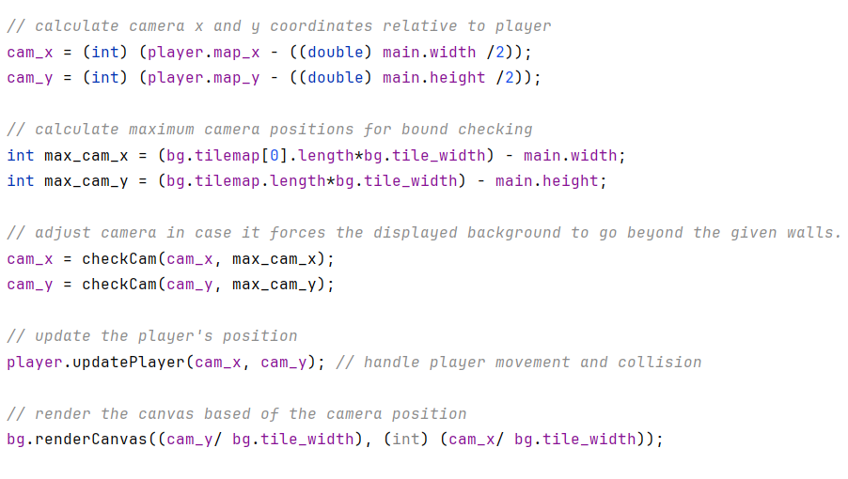

Collision detection
The first part of collision detection was to check if the sprite collided with a wall. This was done by checking to see if the sprite overlapped with any tiles that had a value of 1, representing a wall. If this is true, then I reset the position of the sprite to the previous one.
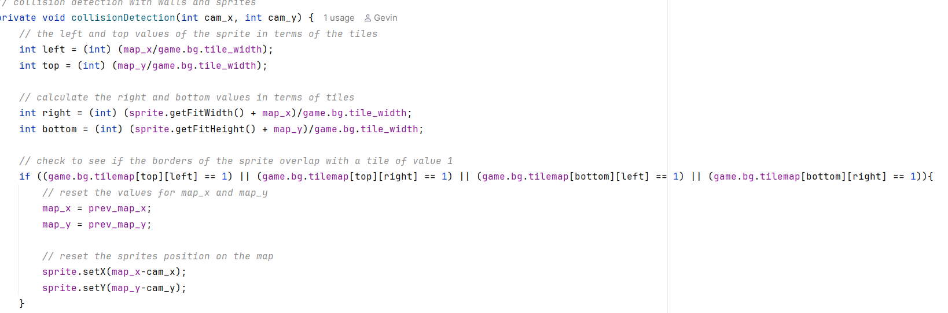
Scene switching
At this time I decided to create a function to switch scenes throughout the game. I created this in the Main class

2.5 Object diagrams and class definitions

2.6 Prototyping

2.7 Design data dictionary and data structures

2.8 File organisation

2.9 E-R model and diagrams, and normalised database tables

2.10 Human–Computer-interface design

2.11 System security and integrity of data

